Risk Based Approach to Unauthorized Practice

Version
Version | Comments | Author
1.0 | Approved by Council on May 31, 2022 | B. Maloney

Background
The Association of Ontario Land Surveyors (AOLS) has dealt with a variety of unauthorized practices over the last several years. Normally the Registrar takes the lead on addressing these and brings other individuals in as required. During the recent statutory function review completed by Richard Steinecke, he identified the need to document practices regarding unauthorized practices (Recommendation 32). This document sets out the process and considerations to address unauthorized practice.

Statutory Provisions
Like all professional bodies, part of the responsibilities of the Association of Ontario Land Surveyors (AOLS) is to ensure that the public is protected from non-professionals undertaking work that is protected by its governing legislation.
The AOLS is governed by the Surveyors Act. The Act prevents individuals, corporations or partnerships from practicing cadastral Surveying.
“11 (1) No individual shall engage in the practice of cadastral surveying or hold himself or herself out as engaging in such a practice unless he or she holds a licence under this Act. 2009, c. 33, Sched. 22, s. 11 (14).
Exception
(2) Despite subsection (1), an individual who does not hold a licence under this Act may perform an act that is within the practice of cadastral surveying if he or she does so at the direction of and under the supervision of a licensed member. 2009, c. 33, Sched. 22, s. 11 (14).
Professional responsibility
(3) A licensed member who supervises and directs the performance of acts that are within the practice of cadastral surveying by individuals referred to in subsection (2) is subject to the same standards of professional conduct and competence in respect of the acts and the related practice of cadastral surveying as if the acts were performed directly by the licensed member. 2009, c. 33, Sched. 22, s. 11 (14).
Operating a business
(4) No individual, corporation or partnership shall operate a business that offers or provides services that are within the practice of cadastral surveying to the public unless the individual, corporation or partnership holds a certificate of authorization to do so issued under this Act. 2009, c. 33, Sched. 22, s. 11 (14).
Proof of practising cadastral surveying
(5) For the purposes of establishing a contravention of subsection (1) or (4), proof of the performance of one act in the practice of cadastral surveying on one occasion is sufficient to establish that a person has engaged in the practice of cadastral surveying. 2009, c. 33, Sched. 22, s. 11 (14).”
“13 (2) No person shall hold himself or herself out as a registered member of the Association unless the person holds a certificate of registration issued under this Act. 2009, c. 33, Sched. 22, s. 11 (16).”
Nor can companies hold themselves out as Ontario Land Surveyors.
“Use of “O.L.S.” by corporation
37 (1) A corporation whose name includes the title “Ontario land surveyor” or “arpenteur-géomètre de l’Ontario” or the initials “O.L.S.” or “A.-G.O.” and that ceases to hold a subsisting certificate of authorization shall not carry on or engage in any business until the title “Ontario land surveyor” or “arpenteur-géomètre de l’Ontario” or the initials “O.L.S.” or “A.-G.O.” are removed from the name of the corporation.
Exception
(2) Subsection (1) does not apply to prevent a corporation from carrying on an activity necessary to the winding up of the corporation. R.S.O. 1990, c. S.29, s. 37.”
The AOLS can apply to the Superior Court to prevent further unauthorized practice.
“Proceedings to prohibit continuation or repetition of contravention
38 Where any provision of this Act or the regulations is contravened, despite any other remedy or any penalty imposed, the Association may apply to a judge of the Superior Court of Justice for an order prohibiting the continuation or repetition of the contravention or the carrying on of any activity specified in the order that, in the opinion of the court, will result or will likely result in the continuation or repetition of the contravention by the person committing the contravention, and the judge may make the order and it may be enforced in the same manner as any other order or judgment of the Superior Court of Justice. R.S.O. 1990, c. S.29, s. 38; 2006, c. 19, Sched. C, s. 1 (1).”
Penalties are prescribed under the Act as well.
“39 (1) Every person who contravenes section 11 is guilty of an offence and on conviction is liable for the first offence to a fine of not more than $15,000 and for each subsequent offence to a fine of not more than $30,000.
Idem
(2) Every person who is not a member of the Association and who uses the title “Ontario land surveyor” or “arpenteur-géomètre de l’Ontario” or the initials “O.L.S.” or “A.-G.O.” as an occupational designation is guilty of an offence and on conviction is liable for the first offence to a fine of not more than $5,000 and for each subsequent offence to a fine of not more than $15,000.
Idem
(4) Every corporation that contravenes section 37 is guilty of an offence and on conviction is liable for a first offence to a fine of not more than $5,000 and for each subsequent offence to a fine of not more than $15,000.
Idem, director or officer of corporation
(5) Where a corporation is guilty of an offence under subsection (1), (2), (3) or (4), every director or officer of the corporation who authorizes, permits or acquiesces in the offence is guilty of an offence and on conviction is liable to a fine of not more than $30,000.”
Actions against unauthorized practice must be taken within two years.
“Limitation
(6) Proceedings shall not be commenced in respect of an offence under subsection (1), (2), (3), (4) or (5) after two years after the date on which the offence was, or is alleged to have been, committed. R.S.O. 1990, c. S.29, s. 39.”
If the defendant is proven to have committed unauthorized practice, they have the burden of proof to prove they have a licence and certificate of authorization under the Act
“Onus of proof
41 Where licensing or the holding of a certificate of authorization under this Act is required to permit the lawful doing of any act or thing, if in any prosecution it is proven that the defendant has done such act or thing, the burden of proving that the defendant was so licensed or that the defendant held a subsisting certificate of authorization under this Act rests upon the defendant. R.S.O. 1990, c. S.29, s. 41.”
It is key to understand the definition of the practice of cadastral surveying when taking any action against unauthorized practice.
“1 “practice of cadastral surveying” means advising on, reporting on, conducting or supervising the conducting of surveys to establish, locate, define or describe lines, boundaries or corners of parcels of land or land covered with water; (“exercice de la profession d’arpenteur cadastral”)”

Options to Address Unauthorized Practice
It is important that the AOLS performs its function of preventing unauthorized practice, however, there are several options to address it:
- Do Nothing – This option only makes sense where there is insufficient evidence of the occurrence of unauthorized practice, or it is questionable that unauthorized practice has occurred as a result of the allegations
- Cease-and-Desist Letter – This is normally the first course of action, and a letter would be issued by the Registrar informing the individual, corporation, or partnership of the alleged occurrence of unauthorized practice and telling them to cease such activity.
- Court injunction – Where the unauthorized practice is serious, or reoccurring seek a judge’s order prohibiting the continuation or repetition of the contravention.
- Fine – Where the unauthorized practice is serious, or reoccurring seek a penalty in accordance with Section 39
- Publication – Where a court injunction has been issued publication is appropriate to advise the public of AOLS actions, the decisions and to further deter the individual from repeating the offence.
- Other Professional Associations – Where the offender is a member of another professional association consideration should be given to launching a complaint with their regulator.

Risk Considerations
Consideration should be given to the risk presented to the public in determining the seriousness of the offence and the course of action.
Risk should consider:
- The frequency of unauthorized services being provided to the public (e.g. is this a regular occurrence as part of their practice or is it a one-time event that is not likely to reoccur)
- The impact of the unauthorized services to the public (i.e. what harm can or is likely to come). This should consider the likelihood and impact of the harm. Services that have a low likelihood and low impact obviously require less attention that those of high likelihood and impact
Seriousness of the offence will normally be determined based on the risk to the public with high-risk actions being the most serious. Additionally, where an individual, company or partnership holds themselves out as Ontario Land Surveyors without having a licence, the matter is considered serious since their actions can tarnish the reputation of the profession and all of its members. (See Appendix A)

Process
The AOLS does not actively seek unauthorized practice. It relies on members and/or the public to discover and alert the AOLS of possible unauthorized practices.
Concerns of unauthorized practice should be forwarded to the Registrar. The Registrar shall investigate and address the matter as follows.
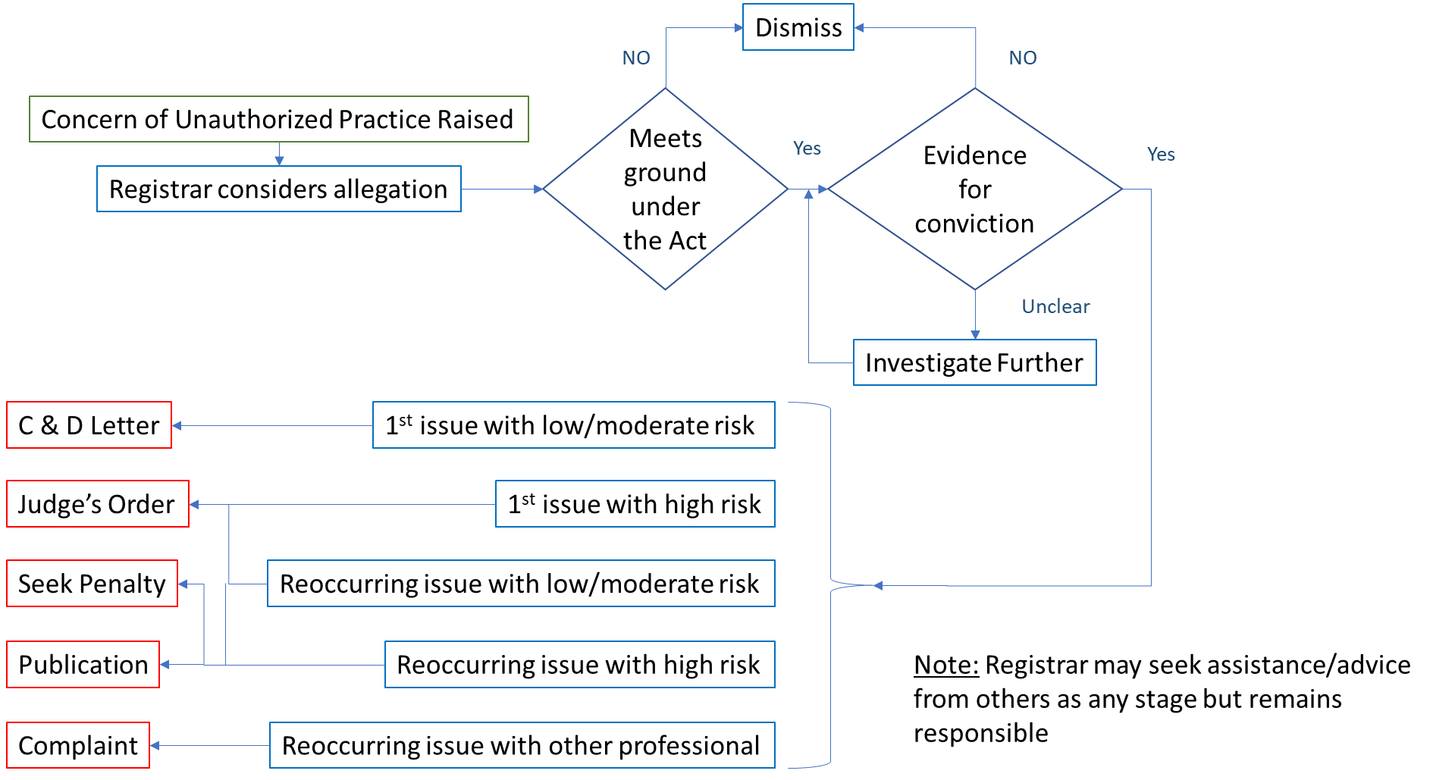

Consideration of allegation
It is up to the Registrar to consider the allegation of unauthorized practice. They may choose to consult with others in making their decision, but the decision ultimately remains with them.
The first consideration is does the allegation appear to be an offence considering the provisions in the Surveyors Act? Many surveyors take a broad interpretation of Cadastral Surveying, which is broader than the definition in the Act that would likely be interpreted by the Courts. We have limited case law regarding unauthorized practice of cadastral surveying in Ontario, although we have been successful in having Judge’s Orders to prohibit or refrain practices. One case has been tested in the Court of Appeal (Association of Ontario Land Surveyors and William Van Loon and Van Loon Construction Surveys & Layout Inc. 2004 CanLII 8847 (ON CA)). The definition is clearly related to the act of surveying and not necessarily boundary opinion. If a boundary is provided without surveying (e.g., relying on GIS data or an existing surveyor’s plan, unfortunately it is not a breach of the Act and cannot be dealt with. If surveying of a boundary is involved, then it is likely unauthorized practice.
The second issue in considering an allegation is the evidence available to demonstrate that cadastral surveying has taken place or that an individual, corporation, or partnership has held themselves out as Ontario Land Surveyors. The AOLS cannot rely on hearsay evidence and must have physical or direct oral evidence available that would be suitable to present in a court. If mechanisms are available to acquire evidence the process can proceed but actual evidence is required prior to taking any action. This may require further investigation beyond the original allegation.

Actions
The action taken will depend on the potential for public harm and whether the individual, corporation, or partnership is reoffending.
The potential public hard should consider the value and consequences of the potential harm. Positioning a fence in the wrong location could certainly have a smaller impact then locating a permanent structure such as a house. The potential for legal action may also be a consideration since it can be expensive to reach a solution.
An individual, company or partnership holding themselves out as Ontario Land Surveyor(s) is considered serious since it is fraudulent and could appear very poorly on the profession.
Unless the unauthorized practice is very serious the first step would be to send a cease-and-desist letter through registered mail requesting the individual, corporation, or partnership to stop and refrain from the unauthorized practice. It they respond positively and stop the unauthorized practice then that would normally be the end of the process. If they don’t respond an effort should be made to contact them and determine their position. If they still do not respond or refuse to stop the unauthorized practice, then an application should be made to the Superior Court of Justice for an order to prohibit the unauthorized practice.
Similarly, if an individual, corporation, or partnership continues the unauthorized practice after being provided a cease-and-desist letter, then an application should be made to the Superior Court of Justice for an order to prohibit the unauthorized practice.
If the AOLS is going to the trouble of making application to the Superior Court, they should also ask that a penalty be applied consistent with the Act. The penalty sought should normally be the lower limit unless the individual has shown absolute disregard for their actions, in which case, an argument should be made for a higher penalty.
Where an individual belonging to another regulated profession performing unauthorized practice has declined to correct their behaviour or has continued the unauthorized practice after being warned, the Registrar, should launch a complaint with their regulator.
If a judge makes and order to prohibit the unauthorized practice, the order should be published on the AOLS public website, in the Ontario Professional Surveyor Magazine and in local newspapers where the offender practiced.

Appendix A – Examples of unauthorized practice leading to harm by level of seriousness

Serious
Individual or firm holding themselves out as Ontario Land Surveyor(s)
Individual or firm performing boundary surveys for building construction purposes
Individual or firms making a living from performing boundary surveys
Moderate
Municipality providing surveys to identify boundaries
Low
Company inadvertently surveying a boundary as part of a grading project
Individual or firm providing fencing surveys

